

**FED RATES IMPACT ON DOW JONES**

**ANALYSIS DONE THROUGH R**

BY- HARSH RAJ J011

MUKTESH J022

SANCHIT AGRAWAL J034

AAYUSH J035

**INTRODUCTION:**

Federal Funds Rate , the rate at which banks borrows from and lend to each other overnight -has a strong effect across the entire U.S economy including the US stock market as assumed by the existing models and the analysists working on it.

As per the basic economic model Higher Interest rate trend to negatively affect the earnings and the stock price , higher interest rate also means future discounted valuation are lower as the discount rate used for future cash flow is higher.

So we have done a brief analysis using a VAR(Vector autoregressive model ) to find if there is any impact of fed on the Dow Jones market and can we use the rates to predict the future of the market . In the analysis we have taken the help of various R libraries like -vars,tseries,tidverse and forecast.

Data set used by us is the DOW -JONES index from 1992 to 2022 and the same time period for FED rates . Dataset taken is monthly.

**MODELLING:**

We have started our process by preparing a data set which contained the fed rates and the DOW Jones index from 1992 to 2022(oct) as mentioned above .

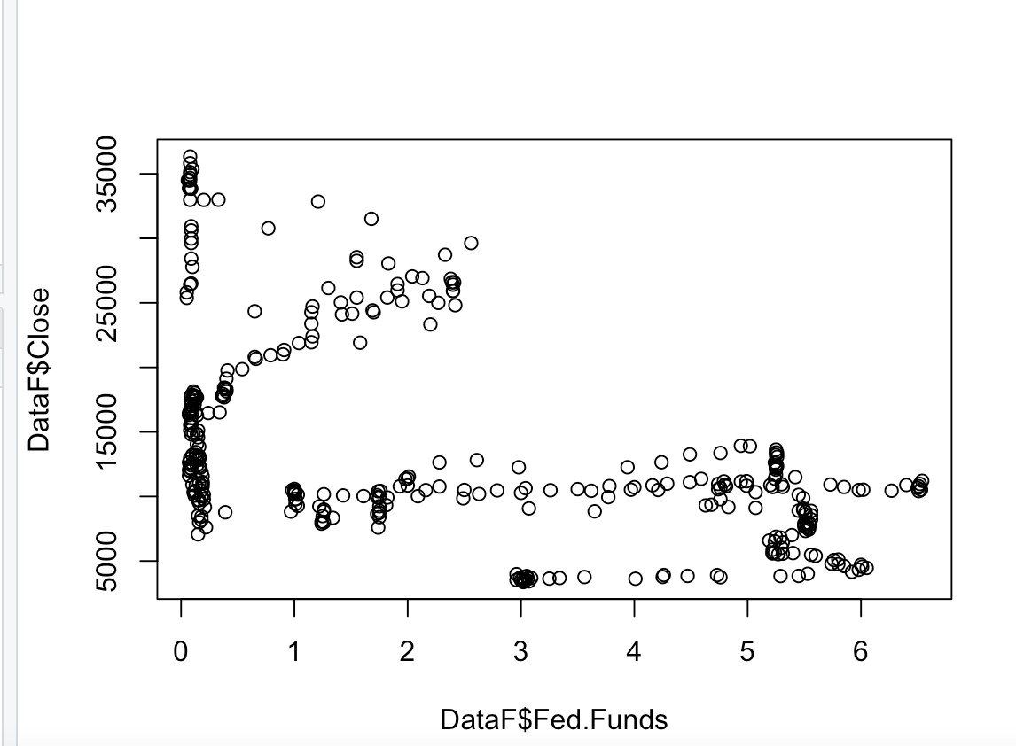

The Scatter plot Graph presented above shows a Distribution chart of Dow jones index daily closing vs The fed rates . It can be seen through the graph that there is some relation between them but it is not consistent and is not able to hold for a long period of time. Then we try to find the outliers of the data to check if there is some similarities between Fed and Dow Jones index and find out that recent outlier position is common in both of them .

Later we convert the fed rates and the Dow index into a time series data set with frequency of 12 month . And plot it .

Dow Jones (1992-2022) Fed Rates(1992-2022)

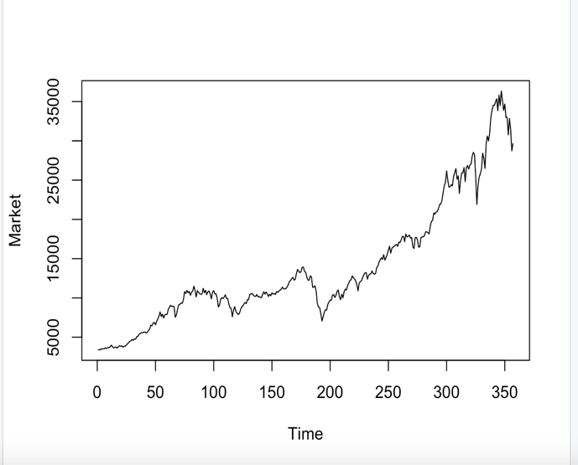 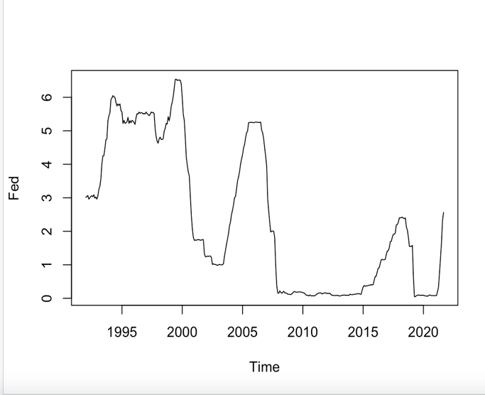

Next we try to find the outliers in both the data set individually and check if the outliers matches in both of the data set individually . Even thou this doesn’t signify much but we just do this to check is something abnormal is happening.

After doing the tsoutlier model on both the data set we find out that data point at September 2022 shows common in terms of outliers.

Moving forward we plot there ACF and PACF plot in the hope of seeing some correlation that they have with themselves but the result comes negative in that too clearly seen from graphs. There Is also decay over long period of time in both FED and DOW-JONES acf graph.

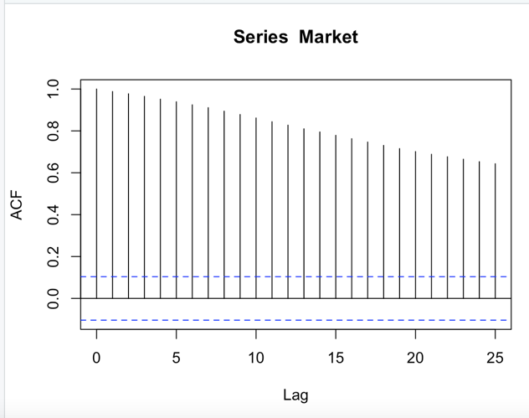 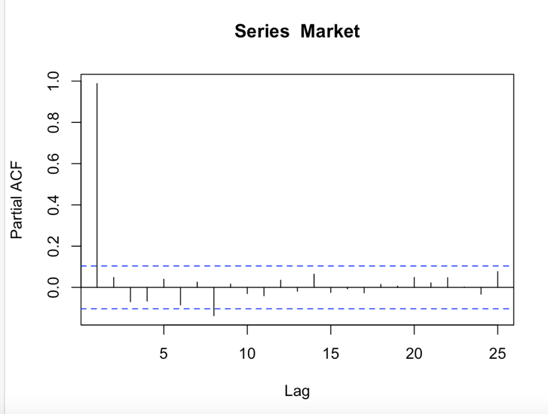

DOW JONES MARKET ACF AND PACF REPRESENTAION

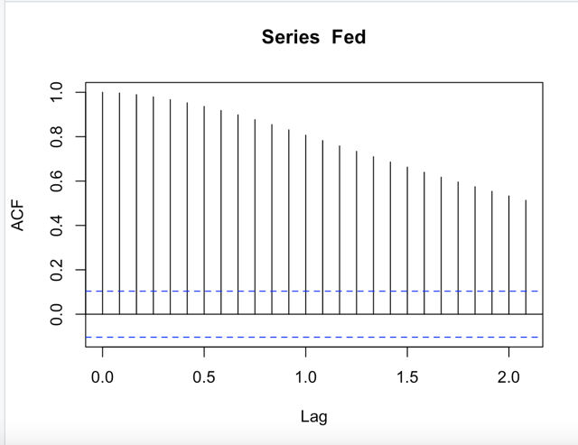 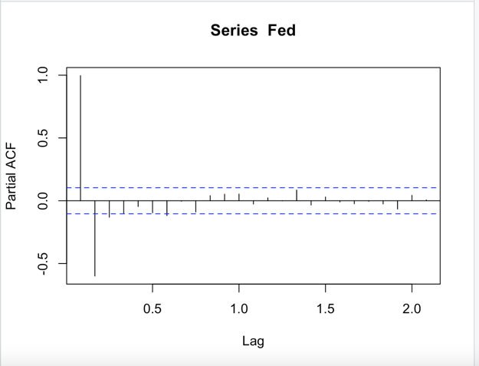

FED RATE ACF AND PACF GRAPH

**MODEL DIAGNOSTICS:**

One of the assumptions that we have considered the residual be non-autocorrelated so to test it we are running serial.test() function to check the hypothesis.

Arch test is also done to signify our heteroscedasticity of our model.

**VAR MODELLING:**

We begin the process of finding some auto correlation between the two data set by running varSelect on them and finding the best lag to suit their model. After applying the lag we stabilize the model by checking there eigen values.

Most important phase of the modelling stars as we do the granger causality test on the data sets by changing their positions vice versa .This test tells us if they are correlated to each other or not .

The result comes a bit surprising as it shows that market effects the rate but not vice versa. To concrete these findings we plot there impulse response in 95% interval to check if our findings are correct.

**PLOTTING THE IMPULSE**

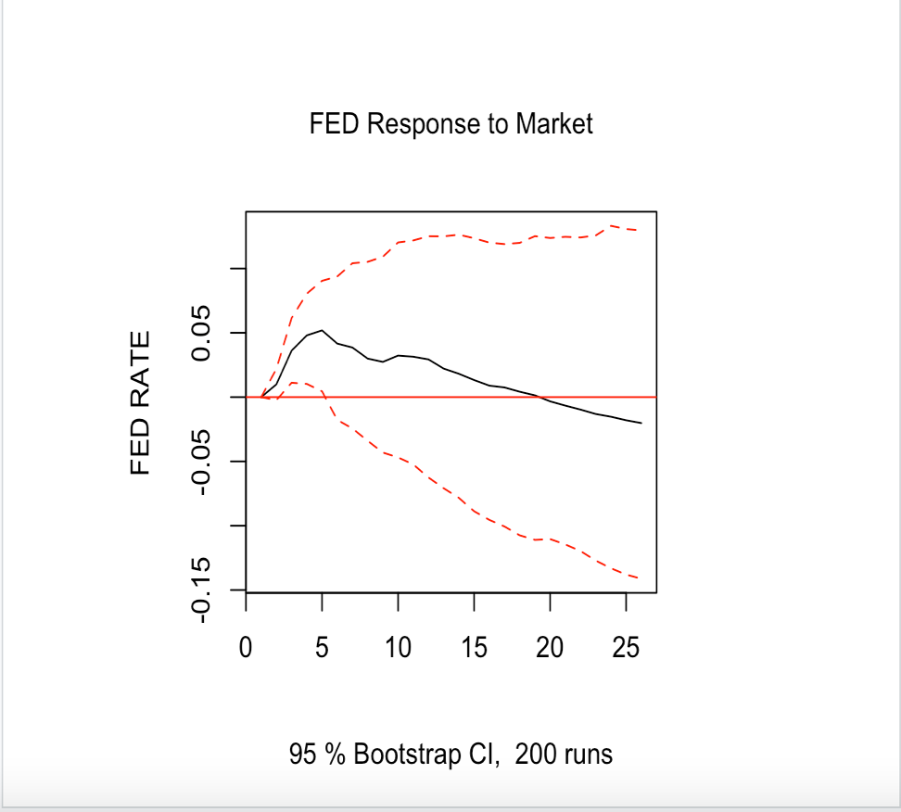

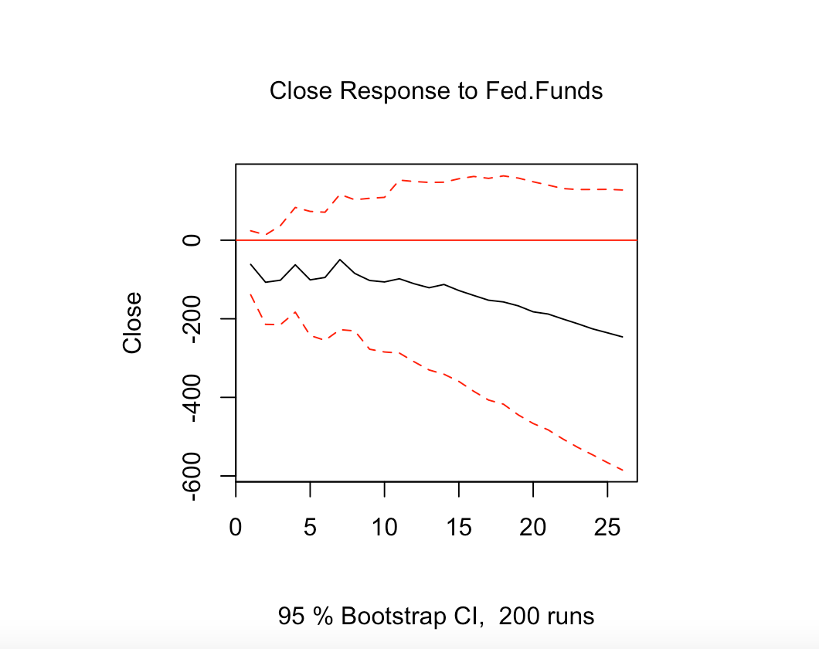

RED LINES SHOWING THE 95%CONFIDENCE INTERVAL

**FORECASTING**

Now we predict next 12 month value for both of our components FED rates and the Stock Market and once we plot it with the help of the fanchart we can see that our model gives a very accurate prediction as per the current trend , solidifying the fact that our model is working accurately but the correlation between them still does not exist.

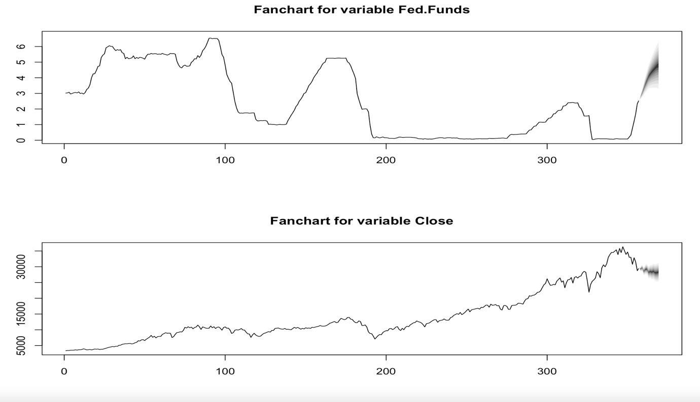

**INFERENCE:**

These plots clear our confusions and findings that we have made till now ,.these plots that there is no proper autocorrelations between the data sets as there confidence interval is extremely large. The previous information that we found that market has an impact on the fed rates might happen because the model was simply finding the similar data pattern and not looking for their direct impact on each other.